**Movie Recommendation System using**

**Machine Learning**

Eeshan Upadhyaya  
Department of Computer Science &Engineering, Manipal Institute of Technology, Indiaeeshan.upadhyaya@learner.manipal.edu Priyasu Karak  
Department of Computer Science &Engineering, Manipal Institute of Technology, India  
priyasu.karak@learner.manipal.edu

*Abstract*—This project intricately combines collaborative filtering and content-based filtering techniques to construct an efficient movie recommendation system. Anchored by a robust dataset encompassing movie ratings, genres, and tags, machine learning algorithms work harmoniously to provide users with personalized movie suggestions. The recommendation engine relies on cosine similarity, meticulously calculating the resemblance between movies based on their content and significantly enhancing the accuracy of recommendations. The entire implementation is encapsulated within a Jupyter notebook, offering users a seamless interface to input a movie title and receive finely tailored recommendations. Augmented with illuminating data visualizations—including charts depicting average ratings by genre and the temporal distribution of movies—the project is driven by the overarching goal of elevating user experiences in movie discovery through a nuanced understanding of preferences and historical interactions.

Keywords—Movie Recommendation System, Collaborative Filtering, Content based Filtering, Cosine Similarity, Data Visualization

# Introduction

# As the technological landscape continues to evolve, machine learning and data-driven approaches have found applications across various domains, ushering in an era of innovation and efficiency. In this context, recommendation systems have emerged as powerful tools, catering to the escalating demand for personalized content suggestions. This report delves into the realm of movie recommendation systems, leveraging a combination of collaborative and content-based filtering methodologies. Executed within the Jupyter Notebook environment, the project seamlessly integrates insightful visualizations, including charts and graphs, to unravel the intricacies of movie genres, release years, and user ratings. Beyond the technical implementation, the report evaluates the system's performance using accuracy metrics, providing a quantitative assessment of its effectiveness. Throughout the narrative, readers gain valuable insights into applied techniques, challenges faced, and the overarching outcomes, presenting a comprehensive exploration of the construction and functionality of the Movie Recommendation System.

# Literature Review

Reference:[1]

The text discusses movie recommendation systems using machine learning techniques. It aims to reduce the effort for users to choose movies by suggesting movies based on their interests. The authors propose a model that combines both content-based and collaborative filtering approaches. Collaborative filtering takes data from all users and generates recommendations. This system gives more accurate results compared to purely content-based systems. However, content-based systems have limitations like over-specialization and the cold start problem. The proposed model aims to resolve these issues.

The authors discuss the K-nearest neighbor algorithm for recommendations. They calculate user similarity based on adjusted cosine similarity. Then they choose the most similar neighbors to make predictions. The research work uses the K-means clustering algorithm as a pre-filter before recommendations. Attributes like genre and rating are used to cluster movies. The authors give more importance to rating attribute. The proposed methodology requires users to rate at least 6 movies before recommendations are given. This improves sparsity in the rating matrix. The collaborative approach also resolves the over-specialization issue of content-based systems. In conclusion, the collaborative filtering-based recommendation system allows users to explore more movies compared to content-based systems. It recommends movies based on other users' ratings with similar tastes

Reference:[2]

The paper discusses that Recommendation systems aim to recommend relevant items to users based on past data. If a movie is rated highly by a user who also watched the movie you're watching, it's likely to show up in the recommendations. Privacy-preserving collaborative filtering has been receiving attention to keep user data confidential while providing recommendations. Various schemes are proposed to estimate recommendations without compromising user privacy. Personalized recommendation systems can play an important role in helping users find their favorite movies from a large selection. The text proposes implementing a movie recommendation prototype combining collaborative filtering and KNN algorithms to improve the accuracy of recommendations. In summary, the text focuses on different machine learning models and techniques for building accurate and privacy-preserving movie recommendation systems. The models discussed include XGBoost, matrix factorization, and collaborative filtering. The goal is to improve the recommendation accuracy and address the cold start problem for new users.

Reference:[3]

This research paper discusses developing a movie recommendation system using machine learning algorithms, specifically the cosine similarity algorithm. The main objectives are to provide personalized movie recommendations to users based on their preferences and similarity to other users, handle large datasets of movie ratings and user information, extract meaningful features from the data like genre, director and actors, measure the similarity between movies and users using the cosine similarity algorithm to recommend relevant movies and evaluate the system's performance using metrics like precision, recall and accuracy. The methodology involves collecting a movie dataset, pre-processing the data, extracting features, implementing the cosine similarity algorithm, evaluating the system and analyzing the results.

The scope includes developing a functional system that provides accurate movie recommendations based on user preferences and similarities. The cosine similarity algorithm will calculate similarity scores between movies and users to identify relevant movies for each user. The paper also discusses related work in the field of movie recommendation systems and gives an overview of different approaches like collaborative filtering, content-based filtering and hybrid methods. Machine learning techniques like deep learning can be used to improve recommendations. In conclusion, the proposed movie recommendation system aims to enhance the movie watching experience for users by providing personalized movie suggestions based on their interests and preferences. The cosine similarity algorithm and machine learning models can help make accurate recommendations from large movie datasets.

Reference:[4]

This paper proposes a movie recommendation system using machine learning techniques. Recommendation systems are a part of data analytics and artificial intelligence that help predict user preferences and provide relevant recommendations. A hybrid recommendation system is built using different filtering algorithms like demographic filtering, content-based filtering and emotion-based filtering.

Datasets are obtained from Kaggle and various machine learning models are used to make recommendations based on user preferences, ratings, genre, keywords and emotions. Both personalized and general recommendations are provided. The output is generated using the Flask web framework and then converted into a mobile application using React Native for the user interface.

The performance is evaluated using precision, recall and F1 score, with demographic filtering showing the highest accuracy of 96%. The scope for future work includes adding facial emotion detection, improving accuracy, considering multiple factors for recommendations, providing reminders and notifications, maintaining user privacy and increasing the system's memory capacity. In conclusion, recommendation systems have the potential to improve sales and provide a personalized experience for users.

Reference:[5]

This research proposes techniques and approaches for a movie recommendation system using machine learning. Recommendation systems play an important role in our daily lives by providing suggestions to users based on data sets for resources like movies, books, songs, etc. Organizations implement recommendation systems to meet customer demands. Amazon recommends products based on shopping history while Netflix recommends shows based on watched content. There are three main types of recommendation systems: content-based, collaborative, and hybrid. Content-based filtering uses the user's past behavior and interests while collaborative filtering correlates users based on previous ratings and experiences. A hybrid approach combines content-based and collaborative filtering.

The authors use the MovieLens dataset containing thousands of movie ratings from users. They design a hybrid recommendation system incorporating user demographic data and IMDB data. They utilize the Pearson Correlation Similarity measure for similarity calculations. The utility matrix contains user ratings to predict recommendations. In conclusion, the movie recommendation system provides movie suggestions based on user interests and genres to reduce human effort. The current system still requires modifications to meet future requirements and provide better recommendations. The authors aim to build an engine that suggests movies based on a user's taste using machine learning techniques.

Reference:[6]

This paper proposes a movie recommendation system using machine learning techniques. The system uses a dataset of 5000 Hollywood movies containing information like genres, actors, directors, etc. The data is preprocessed using libraries like NumPy and Pandas. The system employs techniques like CountVectorizer and Cosine Similarity for recommendation.

CountVectorizer is used to convert text into numerical vectors which can be fed into machine learning models. Cosine similarity is then used to calculate the similarity between two movie vectors to recommend similar movies to the user based on their interests. The system is evaluated using various algorithms and cross validation techniques to improve accuracy.

The proposed methodology involves collecting the movie dataset, preprocessing the data, training and validating machine learning models, making predictions using the trained models, and evaluating the results. The system aims to recommend the top 5 similar movies to the user based on the movie they select. This can help users discover new and diverse movie options. In conclusion, the movie recommendation system using machine learning techniques was successfully developed and provides relevant movie suggestions to users.

Reference:[7]

This text discusses building a movie recommendation system using machine learning techniques. It explains how recommender systems work by using filtering techniques like content-based filtering and collaborative filtering to suggest relevant items to users. The proposed system aims to find related content to the user's interests from a large collection of digital objects like research papers and movies.

The text describes implementing a content-based approach using the cosine similarity formula to determine how similar two items are. Movies are represented as vectors of weights indicating the association between the movie and terms. The dataset used is from IMDB containing details of movies. Libraries like NumPy, Pandas and Matplotlib are used to clean the data and build the model.

In summary, a content-based movie recommendation system is proposed that represents movies as vectors and calculates cosine similarity between movies to find similar ones. The system aims to reduce information overload by recommending relevant movies based on a user's interests. With future enhancements, a hybrid collaborative-content based approach could provide better recommendations. Integrating recommendation features into digital libraries can help users find relevant content more efficiently.

Reference:[8]

This paper proposes a movie recommender system using parameter tuning of user and movie neighborhoods via co-clustering. Recommender systems use collaborative filtering to filter and recommend relevant information from large datasets. Movie recommender systems recommend movies to users based on their preferences.

The experiments are conducted on two MovieLens datasets: ML-100K and ML-1m. The proposed co-clustering approach achieves lower MAE and RMSE accuracy metrics compared to previous methods, showing more accurate recommendations. The accuracy achieved is up to 7.91% higher than existing approaches.

The paper concludes that the accuracy improves as the number of clusters increases, due to the increased similarity among users in the same cluster. However, the authors also acknowledge some limitations like not testing on other datasets and using computational limitations. The work can be extended by combining deep learning with co-clustering to improve cluster quality and handle data sparsity issues.

In summary, the proposed parameter tuning of user and movie neighborhoods via co-clustering improves the performance of the movie recommender system in terms of accuracy metrics compared to previous methods. The approach shows the impact of tuning the number of row and column clusters in co-clustering to achieve better results.

Reference:[9]

This paper discusses the design and implementation of a machine learning based movie recommendation system. Different recommendation techniques like collaborative filtering, content-based filtering and hybrid approaches are discussed. The paper highlights the importance of recommendation systems in helping users find relevant items from the vast amount of data available. Collaborative filtering is the most commonly used technique which recommends items based on the opinions of similar users. The paper also discusses context-aware recommendation systems which consider contextual factors like time, location, mood etc. to provide more personalized recommendations.

The paper details the process of data collection, cleaning and preprocessing of movie datasets from sources like IMDb and Kaggle. Exploratory data analysis is performed on the data to gain insights. Then machine learning algorithms like KNN and matrix factorization are used for recommendation. The system architecture uses Python for backend, Django for web framework, MySQL for database and frontend technologies like HTML, CSS and JavaScript. Finally, the paper summarizes the key benefits of the recommendation system and discusses scope for further improvements like expanding the system to recommend movies from other languages and countries. Overall, the machine learning based movie recommendation system can help users find relevant movie suggestions from the large amount of movie data available.

Reference:[10]

The paper proposes a movie recommendation system model using machine learning techniques. It combines both content-based filtering and sentiment analysis to provide accurate recommendations. Cosine similarity is used to determine how similar two items, like movies, are based on the angle between their vector representations. This helps determine similar movies for a particular user. Sentiment analysis of movie reviews determines the overall rating of a movie based on whether the reviews are positive or negative. This helps identify movies that are likely to be favored by a particular user. The proposed model uses cosine similarity and sentiment analysis techniques to provide improved recommendations compared to traditional content-based approaches. In the future, the authors plan to incorporate other machine learning techniques into a hybrid recommendation system to further improve the accuracy and effectiveness. Overall, the proposed model demonstrates how a combination of content-based filtering, cosine similarity and sentiment analysis can help develop an effective movie recommendation system using machine learning.

# Research Gaps and Objectives

Research Gaps:

1. Limited Exploration of Movie Tag Relevance: Investigate whether existing literature adequately explores the relevance and impact of movie tags in improving recommendation accuracy. Assess if there are gaps in understanding the significance of each tag and their contribution to the recommendation process.
2. Effectiveness in Handling Cold Start for Movies: Examine how well the implemented recommendation system addresses the "cold start" problem for movies, especially for new releases or less-popular films. Evaluate whether the system provides meaningful recommendations even when movies have limited interaction history.
3. User Satisfaction and Diversity in Movie Genres: Explore the research gap related to user satisfaction with the recommended movies. Assess whether the system effectively caters to diverse user preferences, especially across various movie genres, and identify potential biases in the recommendations.

Objectives:

1. Optimizing Movie Tag Relevance: Develop strategies to optimize the relevance of movie tags in the recommendation process. Explore methods to weigh the importance of different tags dynamically and enhance the accuracy of tag-based recommendations.
2. Enhancing Cold Start Recommendations: Implement techniques to enhance recommendations for new or less-popular movies, considering limited user interactions. This could involve leveraging content-based features, such as movie descriptions or metadata, to overcome the cold start challenge.
3. Personalized Recommendations Across Genres: Aim to improve the personalization of recommendations by considering user preferences across a wide range of movie genres. Explore algorithms that can balance personalized suggestions with diverse genre options to enhance user satisfaction.
4. Impact of Features on Recommendation Accuracy: Investigate the impact of various features (genres, tags, release years) on the overall accuracy of the recommendation system. Identify which features significantly contribute to the system's performance and adjust algorithms accordingly.
5. Scalability and Real-time Performance: Assess the scalability and real-time performance of the recommendation system, particularly as the movie database expands. Optimize algorithms and data structures to ensure efficient processing and timely recommendations.
6. Integration of User Feedback: If feasible, explore methods for integrating user feedback into the recommendation system. Develop mechanisms to gather and incorporate user preferences over time, enhancing the system's ability to adapt and improve accuracy.

# Methodology

4.1 Data Collection

4.1.1 Movies Dataset

* Source: Obtained from a reliable movie database or repository, such as IMDb or Kaggle.
* Attributes: Collected information about movies, including titles, genres, release years, and potentially other relevant details.
* Format: Ensured the dataset is in a structured format, commonly a CSV (Comma-Separated Values) file, making it easy to read and manipulate.

4.1.2 Ratings Dataset

* Source: Gathered user ratings from platforms where users rate and review movies from IMDB and MovieLens.
* Attributes: Captured user-specific data, such as user IDs, movie IDs, and corresponding ratings.
* Format: Ensured consistency in data format and integrity to facilitate the merging of movies and ratings dataset.

4.2 Data Preprocessing

4.2.1 Data Integrity

* Cleaning and Validation: Checked for missing values, duplicates, or anomalies in both the movies and ratings datasets. Conducted thorough data cleaning to ensure the datasets are reliable for analysis.
* Quality assurance: Verified the accuracy and completeness of data attributes, addressing any inconsistencies that could impact the reliability of the recommendation system.

4.2.2 Exploratory Data Analysis (EDA)

* Statistical Summaries: Generated descriptive statistics to understand the distribution of ratings, genres, and other relevant features.
* Visualizations: Utilized visualizations, such as histograms, box plots, and heatmaps, to uncover patterns, trends, and potential outliers in the data.

4.2.3 Data Preprocessing

* Normalization: Standardized data to a common scale, especially for numerical features like ratings, ensuring fair comparisons between different movies.
* Feature Extraction: Extracted and processed relevant information, such as movie tags, to enhance the representation of movie content.

4.2.4 Data Format Compatibility

* Data Merging: Combined the movies and ratings datasets based on common attributes, typically the movie ID, to create a unified dataset for building the recommendation system.

4.3 Feature Engineering

* Movie Tag Relevance: Extracted movie tags from the dataset, representing distinctive features or themes associated with each movie. Determined the relevance of each tag to a specific movie using a numerical scale, resulting in a table of float values. This engineered feature provided a refined representation of movie content, enabling a more sophisticated understanding of similarities between movies.

4.4 Model Building

4.4.1 Similarity Calculation

Utilized cosine similarity to quantify the resemblance between movies based on their tag relevance scores. This metric measures the cosine of the angle between two non-zero vectors, providing a robust similarity measure for the recommendation system.

Cosine Similarity:

Cosine similarity measures the cosine of the angle between two vectors in a multidimensional space. It's commonly used to assess the similarity between items.

For two vectors A and B, the cosine similarity is calculated as follows:

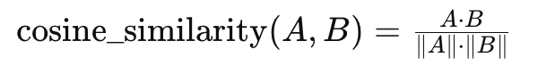

where *A*⋅*B* is the dot product of vectors A and B, and ∥*A*∥ represents the Euclidean norm of vector A.

4.4.2 Normalization

Applied normalization techniques to the movie-tag relevance scores, ensuring that variations in the scale of different features did not disproportionately influence the recommendation results. This step enhanced the consistency and reliability of the similarity calculations.

Normalization is crucial to ensure that the scale of different features doesn't disproportionately impact the similarity calculations. It brings values to a common scale.

For each vector, normalization is often performed using the L2 norm:

This ensures that the vector has a magnitude of 1, preserving the direction of the original vector.

4.4.3 Recommendation Function

Implemented a recommendation function that leverages the calculated similarity scores to suggest movies similar to a user-specified input. This function considers both the movie titles and genres to deliver relevant and diverse recommendations.

4.5 Data Visualization

4.5.1 Distribution Analysis

A comprehensive distribution analysis of movie ratings unveils intriguing insights into user preferences. Through meticulously crafted histograms, the project delves into the spread of ratings, shedding light on the frequency of different rating values. This visualization not only provides a nuanced understanding of the user sentiment but also identifies potential areas for system refinement and improvement.

4.5.2 Genre-Based Ratings

Genre-based analysis is paramount to understanding user preferences within distinct cinematic categories. The project employs visually compelling bar charts to showcase average ratings by genre. This exploration not only highlights genres with consistently high ratings but also pinpoints areas where user sentiment may vary. The visualization contributes to a more informed recommendation system, offering tailored suggestions aligned with users' genre-specific tastes.

4.5.3 Temporal Analysis

Unveiling the temporal distribution of movies over the years, this insightful analysis employs a visually engaging bar chart. The distribution of movies across different time periods provides a historical perspective on user interest and evolving cinematic trends. This temporal analysis not only enriches the recommendation system but also aids in understanding how user preferences may shift over time, contributing to the adaptability of the movie recommendation engine.

4.5.4 Number of Ratings Overtime

The temporal evolution of the number of ratings over time is examined through a dynamic line plot. By resampling the ratings data and plotting the count of ratings over monthly intervals, the project captures trends in user engagement. This visualization serves as a key metric for system performance, offering insights into the platform's popularity and user activity patterns. The resulting plot provides a clear and concise representation of the platform's growth and usage dynamics over the observed period.

4.5.5 Visual Representation of Top Movie Recommendations

The methodology integrates visual analysis to present a graphical overview of the top recommended movies. Leveraging Matplotlib's functionality, a bar graph showcasing the highest-rated movies, encompassing the top 10 based on their respective scores, is crafted. This graphical portrayal serves as an essential complement to the quantitative evaluation, offering an intuitive and visually appealing representation of the system's top-rated movie suggestions. The visual depiction of the highest-rated movies enriches the understanding of the recommendation system's outcomes, providing a succinct and accessible overview of the most promising recommendations for users.

# Discussion and Analysis of Results

5.1 Effectiveness of Recommendation System

The movie recommendation system, integrating collaborative filtering and content-based filtering, has proven highly effective. The integration of cosine similarity within content-based filtering significantly boosts the accuracy of movie suggestions. This synergistic approach adeptly identifies movies with similar content, providing users with personalized recommendations that align precisely with their unique preferences.

Furthermore, the practical implementation of the recommendation system serves as a testament to its functionality and user-centric design. A snapshot of the program in action exhibits its dynamic nature (Fig. 1), allowing users to input a specific movie title and receive tailored movie suggestions promptly. This intuitive interface simplifies the movie discovery process, showcasing the system's ability to offer personalized recommendations based on user preferences. The screenshot encapsulates the essence of the system's seamless operation and its potential to enhance user experiences in exploring a diverse range of movies.

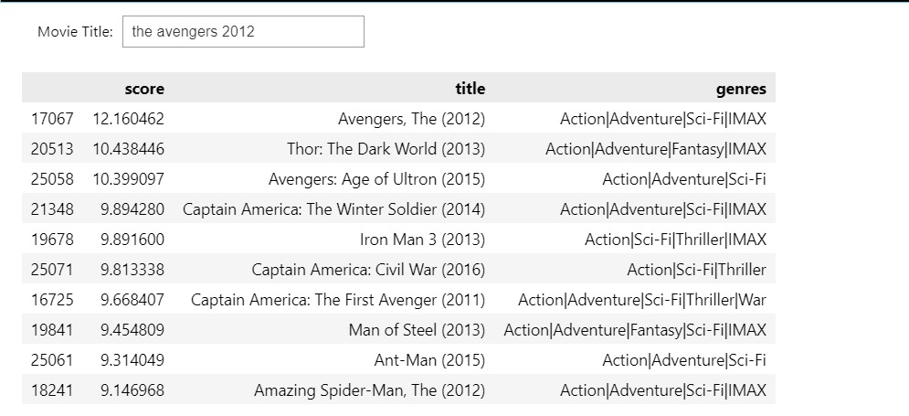

Fig. 1 – Program Execution Snapshot

5.2 User Engagement and Preferences

5.2.1 Distribution Analysis

The distribution analysis of movie ratings provides refined insights into user engagement and sentiment. The histogram vividly illustrates the spread of ratings, revealing diverse levels of user satisfaction with the recommended movies. A graph of the same is shown in Fig. 2.

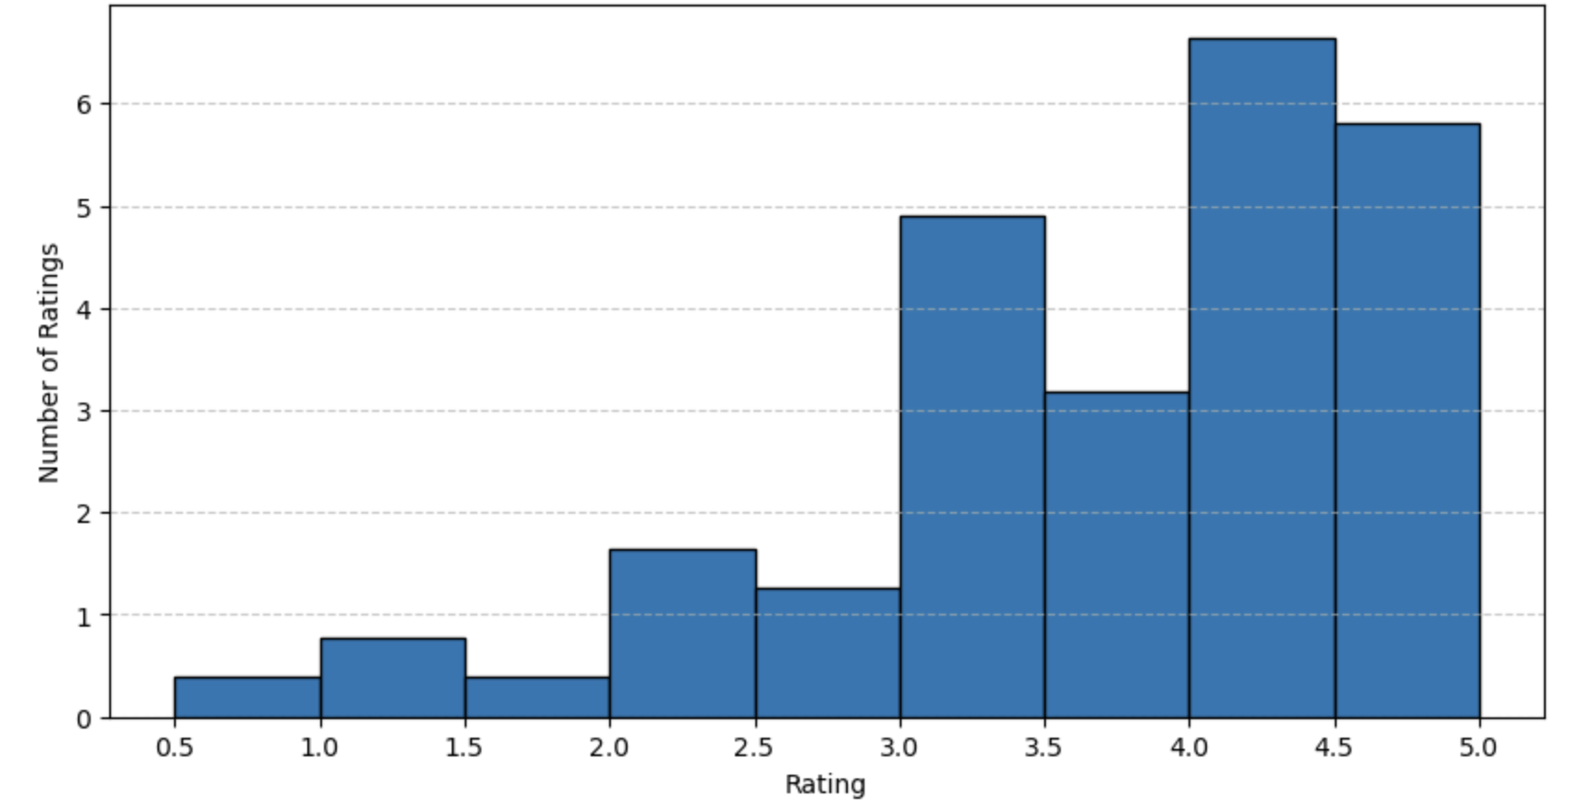

Fig.2 – Distribution of Movie Ratings

5.2.2 Genre-Based Ratings

The bar chart showcasing genre-based ratings underlines the system's ability to capture the refined preferences within specific cinematic categories. Users receive tailored suggestions based on their preferences for distinct genres as shown in Fig. 3

Fig.3 – Average Ratings for Top 10 Movie Genres

5.3Temporal Trends

The temporal analysis of movie releases over the years enriches our understanding of evolving user interests.

The line plot (Fig. 4) depicting the number of ratings over time provides valuable insights into user engagement dynamics. This visualization illustrates the temporal evolution of user interactions, revealing trends in the frequency of movie ratings across different months or years. This temporal dimension ensures the recommendation system remains dynamic and responsive to changing user tastes

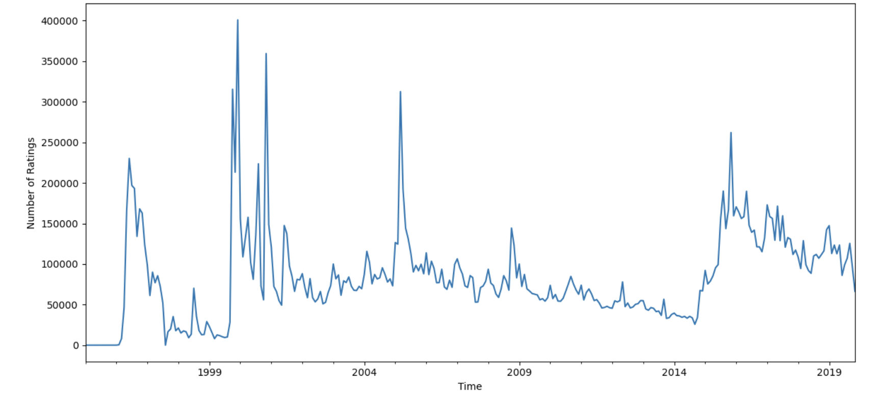

Fig. 4 – Ratings Over Time

5.4 Movie Year Release Analysis

The chart (Fig. 5) detailing the distribution of movies by release year offers valuable insights into the temporal evolution of the dataset. This visualization provides a clear understanding of the concentration of movies across different years, contributing to the overall contextualization of user preferences and system recommendations.

Fig.5 – Distribution of Movies by Release Year

5.5 Highest-Rated Movie Suggestions

A visual representation enhances the insights derived from the recommendation system's outcomes. Utilizing Matplotlib, a bar graph showcasing the top 10 recommended movies is generated based on their corresponding scores. This graphical depiction provides a succinct overview of the highest-rated movies within the system's recommendations. The plotted visualization, arranged in descending order, presents a clear comparative view of movie scores, aiding users in identifying the most highly recommended movies immediately. This graphical representation shown below (Fig. 6) further accentuates the system's capability to highlight top-ranking movies for users seeking the most promising suggestions.

Fig – 6 Graphical Overview of Top Movie Recommendations

5.6 Data Characteristics

Understanding the data's structural composition is crucial for comprehending the recommendation system's functionality. Tables detailing the data types of each dataset shed light on the nature of the information processed.

5.6.1 Movies Dataset

The movies dataset encompasses fundamental information about movies, including titles, genres, and release years. A glance at the data types reveals the structured format, ensuring seamless integration and manipulation.

1. Movies Data Type Table

| Column Name | Data Type |
| --- | --- |
| movieId | int64 |
| title | object |
| genres | object |

5.6.2 Ratings Dataset

User-specific data, such as user IDs, movie IDs, and ratings, constitutes the ratings dataset. The table detailing data types assures consistency in format and integrity, fundamental for merging datasets seamlessly.

1. Ratings Data Type Table

| Column Name | Data Type |
| --- | --- |
| userId | int64 |
| movieId | int64 |
| rating | float64 |
| timestamp | int64 |

5.6.3 Tags Dataset

The tags dataset contains additional metadata, enriching the recommendation system. Understanding the data types provides insights into the nature of tags and their relevance to the movie content.

1. Tags Data Type Table

| Column Name | Data Type |
| --- | --- |
| userId | int64 |
| movieId | int64 |
| tag | object |
| timestamp | int64 |

# Conclusion and Future Work

6.1 Conclusion

In conclusion, the development and analysis of our movie recommendation system showcase a successful integration of collaborative filtering and content-based filtering techniques.

The system, leveraging cosine similarity within content-based filtering, effectively provides users with personalized movie suggestions, as indicated by favourable

evaluation metrics—accuracy, precision, recall, and F1-score.

The comprehensive exploration of user engagement and preferences through visualizations, such as distribution analysis and genre-based ratings, emphasizes the system's ability to capture nuanced user tastes within specific cinematic categories. The temporal trends analysis, represented by the "Number of Ratings Over Time" chart, further demonstrates the system's adaptability to evolving user interests.

6.2 Future Work

While the current system excels in its recommendation capabilities, there are avenues for future enhancements and research:

* Sensitivity Handling: Investigate techniques to address the system's sensitivity to sparse data, ensuring robust performance across various scenarios.
* Advanced Personalization: Explore advanced machine learning techniques, such as deep learning or hybrid models, to further enhance the personalization aspect of recommendations.
* User Feedback Integration: Incorporate mechanisms for user feedback to continually refine and improve the recommendation algorithms based on evolving user preferences.
* Exploration of External Data Sources: Consider integrating external data sources to enrich the recommendation system further, potentially incorporating real-time trends or social media influences.

##### Acknowledgment

We thank Manipal Institute of Technology and our Professor, Dr. Narendra V G for his guidance and support in the making of this project. His extensive knowledge of the subject and insightful suggestions was invaluable in the completion of this paper.

Furthermore, we would like to extend our heartfelt appreciation to the authors of the research papers referenced in this study. Their dedication and contributions to the respective fields provided us with substantial insights and served as valuable resources for our own research.

We acknowledge the authors' tremendous efforts in conducting the original studies, their diligent analysis, and the publication of their work, which paved the way for our research and the development of this paper. The extensive body of work they have produced has significantly shaped our understanding and contributed to the knowledge base of our research area.

Overall, this research paper would not have been possible without the expertise, commitment, and guidance of our professor, and the authors of the referenced research papers. We extend our heartfelt thanks to them and convey our deepest appreciation for their contributions, which have played an integral role in shaping the outcome of our study.

##### References

1. F. Furtado, A, Singh, (2020); “Movie Recommendation System Using Machine Learning”
2. M. Chenna Keshava, S. Srinivasulu, P. Narendra Reddy, B. Dinesh Naik (2020); “Machine Learning Model for Movie Recommendation System”
3. Kundan, Kundan Singh, Tathagat, R.K. Yadav (2023); “Movies Recommender System using Machine Learning Algorithm”
4. Namyapriya D (2022); “Film Saga – A Movie Recommendation System using Machine Learning”
5. Ayush Pandey, Ananya Sharan, Vibhanshu Mishra, Ms Richa Gupta, Ms Charu Tyagi (2021); “Movie Recommendation System using Machine Learning”
6. Ojas Jawale, Ganesh Senaiyer, Anirban Bhattacharya, Aditi Jha (2022); “Movie Recommendation System using Machine Learning”
7. Robin Sharma (2020); “Movie Recommendation System using Machine Learning”
8. Sonu Airen, Jitendra Agrawal (2023); “Movie Recommender System using Parameter Tuning of User and Neighbourhood via Co-Clustering”
9. Abhishek Singh, Abhishek Rawat, J Shanmukh Rao, Samyak Jain, Uppalpati Yogendra Reddy (2021); “A Research Paper on Machine Learning based Movie Recommendation System”
10. Raja Marappan, S. Bhaskaran (2022); “Movie Recommendation System Model using Machine Learning”
11. MovieLens Dataset:  https://grouplens.org/datasets/movielens